session-based recommender system (sr-gnn)

# library link

<https://github.com/CRIPAC-DIG/SR-GNN>

# basic description

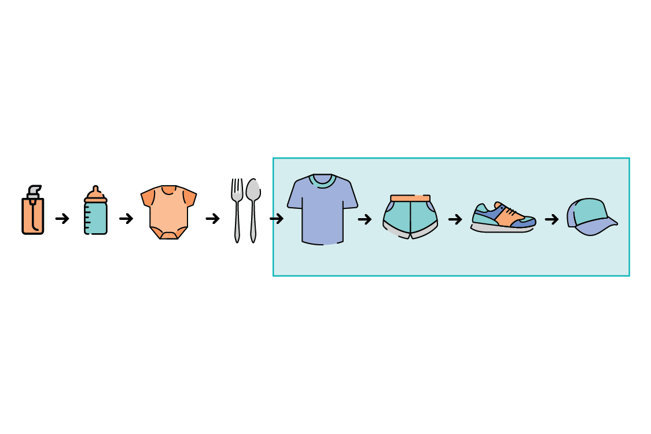

Session-based recommender system refers to a recommendation system that predicts and recommends items to be clicked by a user based on continuous session of a user.

The term 'session' here refers to a specific event and mainly refers to a click(log data).

SR-GNN: Session-based Recommendation with Graph Neural Networks

# version

* Python == 3.6
* Pytorch == 1.6.0 (pip install torch)
* Numpy == 1.18.1 (pip install numpy)

# dataset

* Diginetica dataset

<https://competitions.codalab.org/competitions/11161>

* Yoochoose dataset

<https://www.kaggle.com/chadgostopp/recsys-challenge-2015>

# code description

* Download the code from GitHub.

Dataset for executing code is in a folder, so there is no need to download it.

* Entering the code below within the datasets folder.

python preprocess.py --dataset=sample

* Entering the code below within the pytorch_code folder.

python main.py --dataset=sample

# validation

* x